COMPLETE SUPER-MART SALES DATA ANALYSIS WITH MICROSOFT EXCEL

Michael O. Aboagye
15/11/2025
Tool: Microsoft Excel

Introduction

This project aimed to generate in-depth insights from Supermart sales data using Microsoft Excel as the primary analytical tool. The analysis focused on key business areas, including sales performance, profitability, shipping costs, and the effectiveness of marketing channels. The objective was to produce a comprehensive data analysis report supported by clear visualizations to inform data-driven business decisions.

Data overview
The analysis is based on three datasets: orders_data.xlsx, returns_data.xlsx, and user_data.xlsx. These datasets collectively capture transactional, customer, product, logistics, and managerial information required for comprehensive business analysis.

Dataset Structure and Key Fields

Order Information: Row ID, Order ID, Order Date, Order Quantity, Order Priority

Financial Metrics: Sales, Sales Target, Discount, Profit, Unit Price, Discounted Price

Shipping & Logistics: Ship Mode, Shipping Cost, Ship Date

Customer Details: Customer Name, Zip Code, City, State, Region, Customer Segment

Product Attributes: Product Category, Sub -Category, Product Name, Supplier, Product Container

Marketing & Margins: Marketing Channel, Product Base Margin

User & Management Data: Manager, Assigned Region
Together, these datasets enable detailed analysis of sales performance, profitability, operational efficiency, and marketing effectiveness across different regions and customer segments.

The datasets were modeled in Excel’s power Query. The diagram below shows the model.
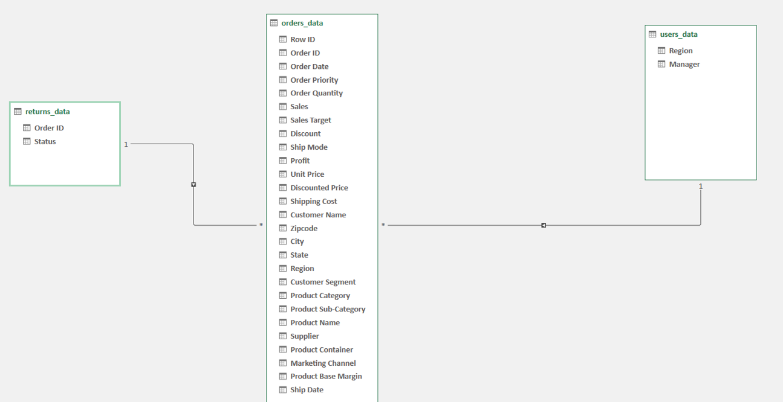
Fig.1 Data model diagram

Methodology
- Imported and cleaned three datasets in Microsoft Excel using Power Query to ensure data accuracy and consistency.
- Performed data quality checks to identify and resolve errors, duplicates, and inconsistencies.
- Analyzed sales performance, profitability, shipping costs, and marketing effectiveness using interactive Pivot Tables and Charts.
- Presented insights through clear, business-focused visualizations for effective reporting.

Metrics and definition
The following key metrics were measured during the data analysis:
- Sales Performance: Evaluation of periodic sales trends across different time periods, product categories, and customer demographics to identify growth patterns and demand drivers.
- Profitability: Measurement of profit levels and margins to assess the financial performance of products, customer segments, and regions.
- Cost of Delivery: Analysis of shipping and delivery costs to determine their impact on overall profitability and operational efficiency.
- Marketing Efficiency: Assessment of marketing channel performance by comparing sales and profitability outcomes across different marketing methods.

Analysis & Findings
- Sales Performance

Quarterly Sales Performance.
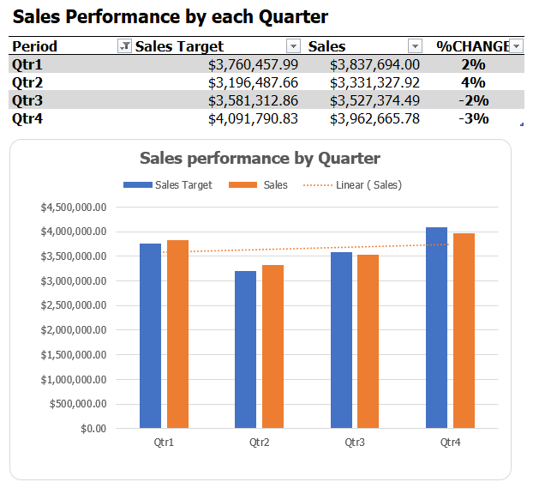
Fig 2. Quarterly sales performance.

Sales targets for Quarter 1 and Quarter 2 were successfully achieved. Although sales continued to increase in Quarter 3 and Quarter 4, the target sales for these periods were not met.

Monthly Sales Performance

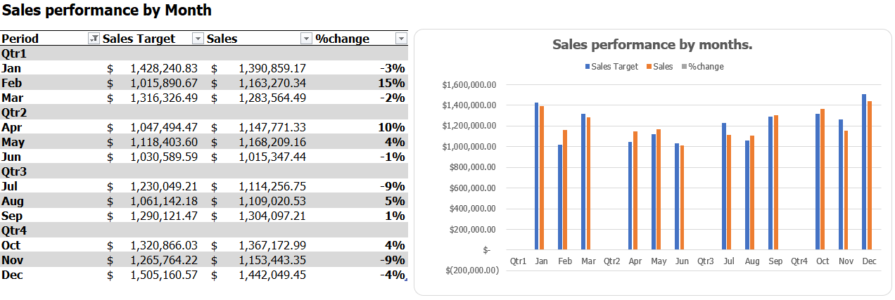
Fig3. Monthly sales performance

The chart above compares monthly sales against targeted sales, grouped by quarter. Sales targets were achieved in February, April, May, August, and September, with February and April recording the highest sales margins.

Sales by region
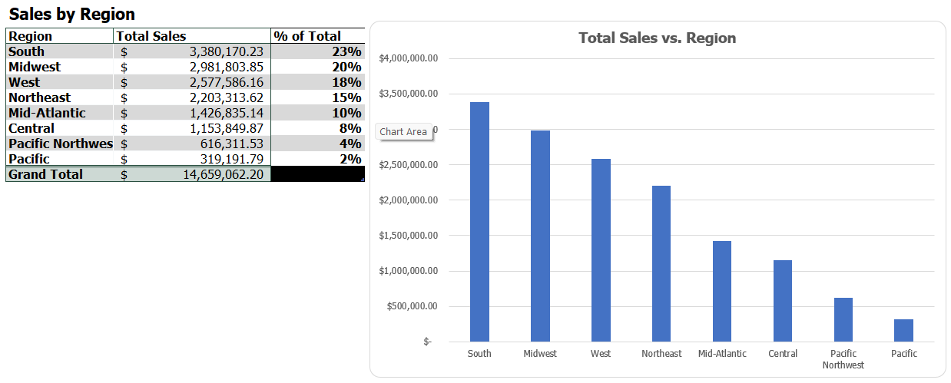

Fig 4. Sales by region

Total sales were arranged in descending order by region. The South recorded the highest percentage of total sales, followed by the Midwest, while the Pacific region ranked last, with total sales of less than $500,000.

Sales by State
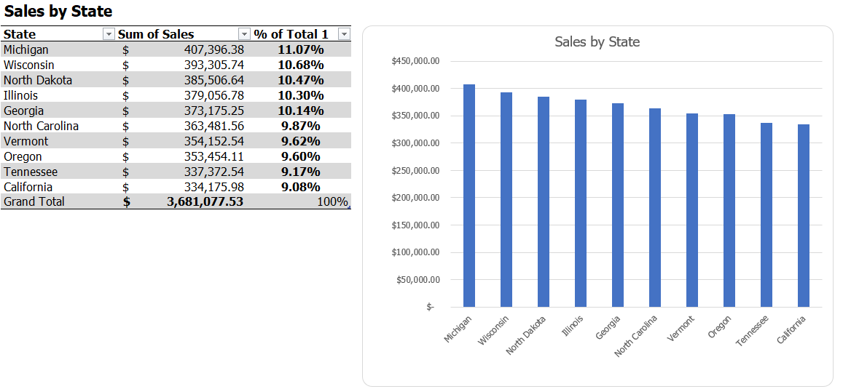
Fig 5. sales by state.

Total sales were grouped by state and presented as a percentage of overall sales. Michigan recorded the highest sales contribution, followed by Wisconsin, while California had the lowest sales share.

Sales by product category
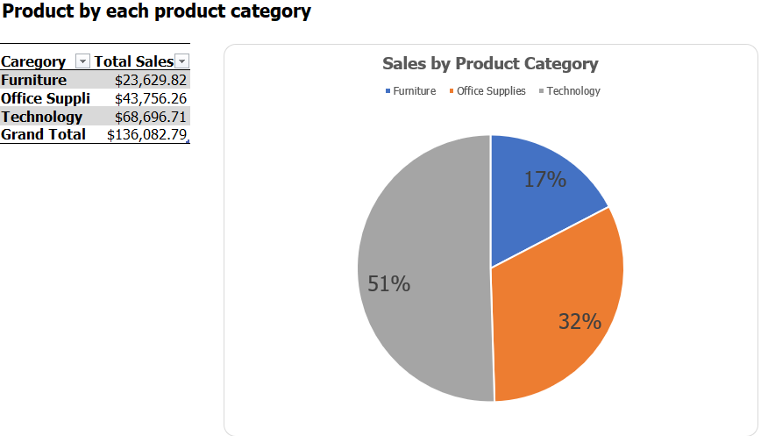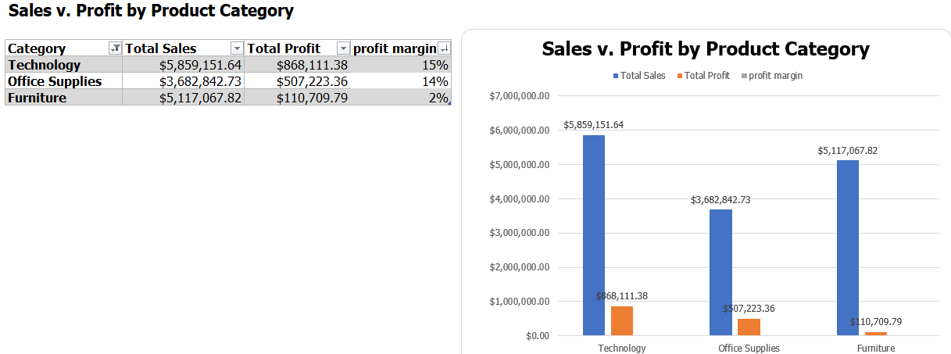
Fig 6. Sales by product category Fig 7. Sales v. profit by product category.

Technology recorded the highest sales contribution, accounting for 51% of total sales, followed by Office Supplies at 32% and Furniture at 17%.

Profitability by city
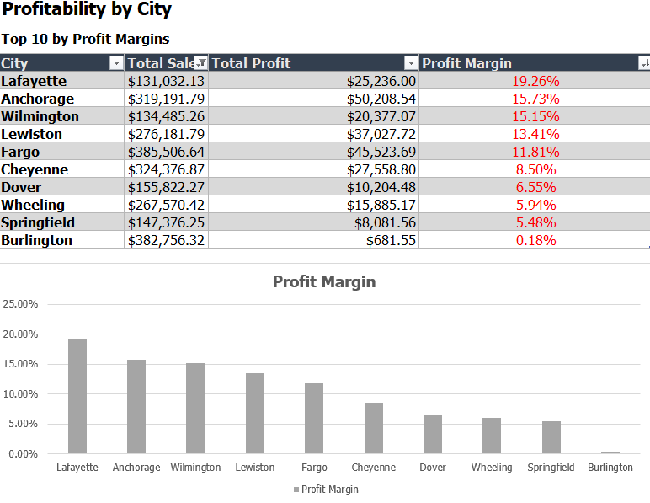
Fig 8. Top 10 performing city by profit margin.

The chart displays the top 10 cities by profit margin. Lafayette recorded the highest margin at 19.26%, followed by Anchorage at 15.73% and Wilmington at 15.15%.

- Shipping cost
Shipping Cost by Delivery Methods Grouped by Regions
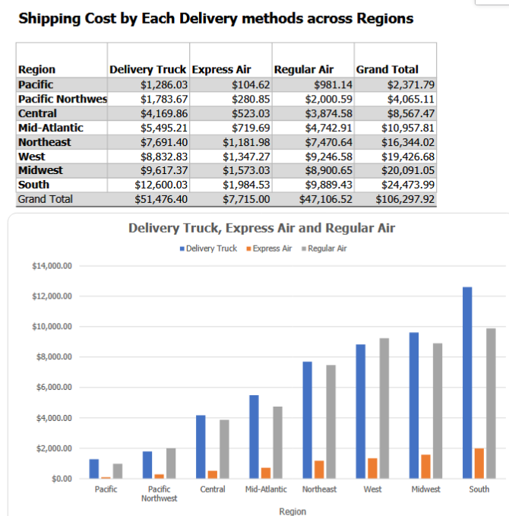
Fig 9. Shipping cost by region
Truck deliveries incurred the highest shipping costs across all regions, with the South region recording the highest expenses.

- Marketing channels
Sales By Customer Segments Grouped by Marketing Channels.
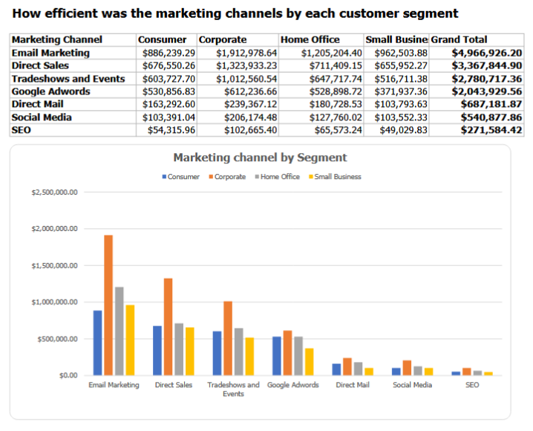
Fig 10. Efficiency in marketing channels.

Email marketing generated the highest sales across all customer segments, with Corporate customers contributing the largest share of sales through this channel.

Total Profit by Marketing Channels

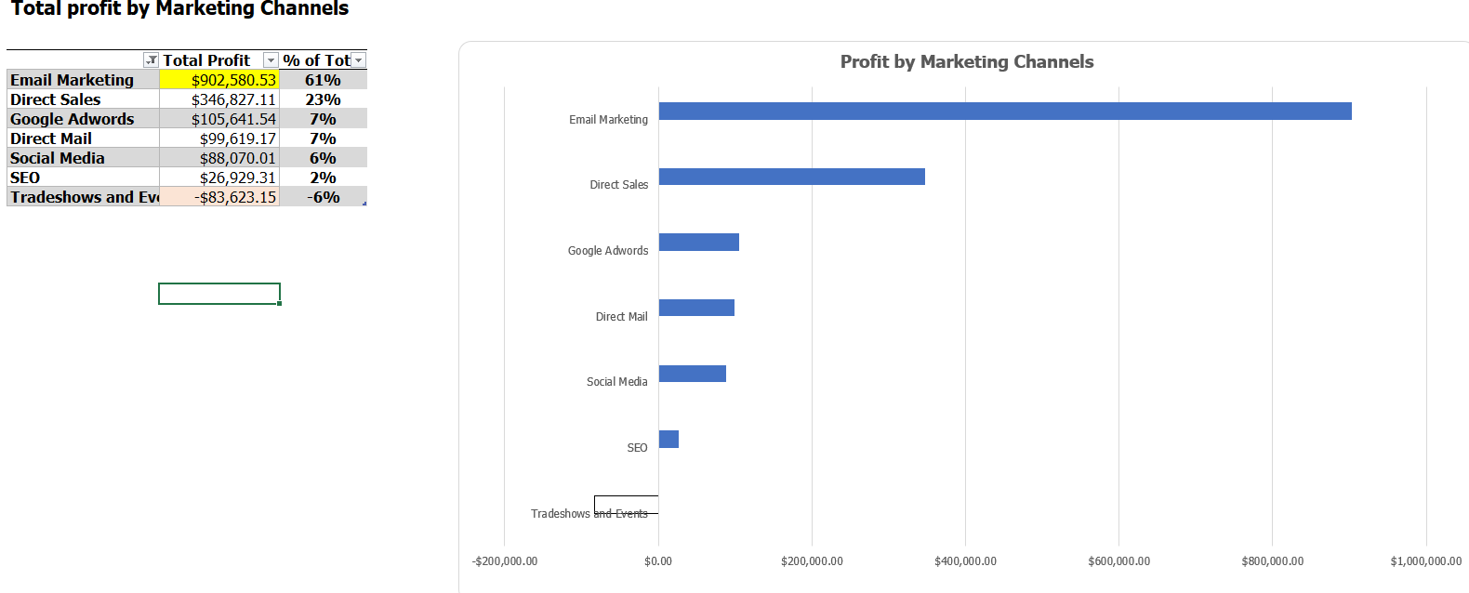
Fig 11. Profitability by marketing channels.

The chart above illustrates total profit across different marketing channels. Email marketing contributed the highest profit at 61% of the total, while Tradeshows and Events generated a negative return of approximately -6%.

Key Insights

- Focus marketing efforts on the most effective channels, such as Email Marketing and Direct Sales.

- Reduce reliance on high-cost delivery methods, particularly truck deliveries, in favor of more cost-efficient alternatives.

- Strengthen marketing initiatives in lower-performing regions, including Pacific, Central, and Pacific Northwest, to boost sales.

